November 2, 2021

Vol. 32, No. 7

For Additional Information:
Dr. John Christy, (256) 961-7763
christy@nsstc.uah.edu
Dr. Roy Spencer, (256) 961-7960
spencer@nsstc.uah.edu

Global Temperature Report: October 2021
(New Reference Base, 1991-2020)

Global climate trend since Dec. 1 1978: +0.14 C per decade

October Temperatures (preliminary)

Global composite temp.: +0.37 C (+0.67°F) above seasonal average

Northern Hemisphere: +0.46 C (+0.83 °F) above seasonal average

Southern Hemisphere: +0.27 C (+0.49 °F) above seasonal average

Tropics: +0.33 C (+0.59 °F) above seasonal average

September Temperatures (final)

Global composite temp.: +0.25 C (+0.45 °F) above seasonal average

Northern Hemisphere: +0.18 C (+0.32 °F) above seasonal average

Southern Hemisphere: +0.33 C (+0.59°F) above seasonal average

Tropics: +0.09 C (+0.16 °F) above seasonal average

Notes on data released November 2, 2021 (v6.0, with new reference base)

The global temperature departure from average continued to rise from a low in June to +0.37 C (+0.67 °F) led by a relative increase in temperatures in the Northern Hemisphere and tropics, primarily over the land areas. This was an unusual situation as the La Niña (cool equatorial Pacific waters) continued to strengthen as this phase of the global climate became more established through the month. However, this level of warmth is essentially the same as was observed in October 2020 (+0.38 C) when the La Niña of that year was also beginning to establish itself. In 2020, the atmospheric cool-down did not begin until December with the peak cooling occurring in April 2021. As can happen in these situations when the equatorial Pacific sea surface temperatures plunge as they have in the past month, some of the expelled heat makes its way to warm up the atmosphere for a month or two. Of course, no two La Niñas are the same, so while we anticipate cooler global temperatures by early 2022, the timing is still uncertain.

NOAA has upgraded the “La Niña Watch” to a “La Niña Advisory” as La Niña conditions are present with an 87% chance of continuing through February. To keep track of the latest weekly summary of the El Niño/La Niña cycle see:

https://www.cpc.ncep.noaa.gov/products/analysis_monitoring/lanina/enso_evolution-status-fcsts-web.pdf.

The global temperature anomaly over land-only of +0.61 C (+1.10 °F) was the warmest such departure for land of the past 43 Octobers in the satellite record, exceeding the +0.54 C observed in 2017. The NH land anomaly was also a 43-year record at +0.71 C (+1.28 °F). The record warm global land-only anomaly for any month of the year was observed in Feb 2016 when the departure reached +0.92 C (+1.66 °F).

The warmest region, in terms of the monthly departure from average, was +6.8 C (+12.2 °F) near Hudson Bay and shows up clearly as the Earth’s hotspot, being one of the highest monthly departures for a specific location in the satellite record. This area of warmer departures extended southward to Mexico and northward almost to the pole. The North Pacific, much of Africa eastward through China, the far South Pacific and eastern Antarctica were also above average.

The coldest grid cell appeared over the far South Pacific near Antarctica at -3.4 C (-6.1 °F). A similar cold area was centered over far NE Russia with cooler air extending eastward to Alaska and southward into the NE Pacific, spreading into the western conterminous US. North central Africa eastward to Kazakhstan was also an area of below average temperatures.

The pattern of warmer temperatures in the western conterminous US vs the eastern states seen over the last several months reversed in October. The 48-state average of +0.84 C (+1.51 °F) indicated the area of above average temperatures was greater than area in the West of below average temperatures. Several Octobers have been warmer with the highest achieved in 2015 at +1.19 C (+2.14 °F). Because Alaska was cooler than average the 49-state departure for October was calculated to be +0.58 C (+1.04°F). [We don’t include Hawaii in the US results because its land area is less than that of a satellite grid square, so it would have virtually no impact on the overall national results.]

New Reference Base Jan 2021. As noted in the Jan 2021 GTR, the situation comes around every 10 years when the reference period or “30-year normal” that we use to calculate the departures is redefined. With that, we have averaged the absolute temperatures over the period 1991-2020, in accordance with the World Meteorological Organization’s guidelines, and use this as the new base period. This allows the anomalies to relate more closely to the experience of the average person, i.e. the climate of the last 30 years. Due to the rising trend of global and regional temperatures, the new normals are a little warmer than before, i.e. the global average temperature for Januaries for 1991-2020 is 0.14 °C warmer than the average for Januaries during 1981-2010. So, the new departures from this now warmer average will appear to be cooler, but this is an artifact of simply applying a new base period. It is important to remember that changes over time periods, such as a trend value or the relative difference of one year to the next, will not change. Think about it this way, all we’ve done is to take the entire time series and shifted it down a little.

To-Do List: There has been a delay in our ability to utilize and merge the new generation of microwave sensors (ATMS) on the NPP and JPSS satellites. As of now, the calibration equations applied by the agency have changed at least twice, so that the data stream contains inhomogeneities which obviously impact the type of measurements we seek. We are hoping this is resolved soon with a dataset that is built with a single, consistent set of calibration equations. In addition, the current non-drifting satellite operated by the Europeans, MetOP-B, has not yet been adjusted or “neutralized” for its seasonal peculiarities related to its unique equatorial crossing time (0930). While these MetOP-B peculiarities do not affect the long-term global trend, they do introduce error within a particular year in specific locations over land.

As part of an ongoing joint project between UAH, NOAA and NASA, Christy and Dr. Roy Spencer, an ESSC principal scientist, use data gathered by advanced microwave sounding units on NOAA, NASA and European satellites to produce temperature readings for almost all regions of the Earth. This includes remote desert, ocean and rain forest areas where reliable climate data are not otherwise available. Drs. Danny Braswell and Rob Junod assist in the preparation of these reports.

The satellite-based instruments measure the temperature of the atmosphere from the surface up to an altitude of about eight kilometers above sea level. Once the monthly temperature data are collected and processed, they are placed in a "public" computer file for immediate access by atmospheric scientists in the U.S. and abroad.

The complete version 6 lower troposphere dataset is available here:

http://www.nsstc.uah.edu/data/msu/v6.0/tlt/uahncdc_lt_6.0.txt

Archived color maps of local temperature anomalies are available on-line at:

http://nsstc.uah.edu/climate/

Neither Christy nor Spencer receives any research support or funding from oil, coal or industrial companies or organizations, or from any private or special interest groups. All of their climate research funding comes from federal and state grants or contracts.

--30—

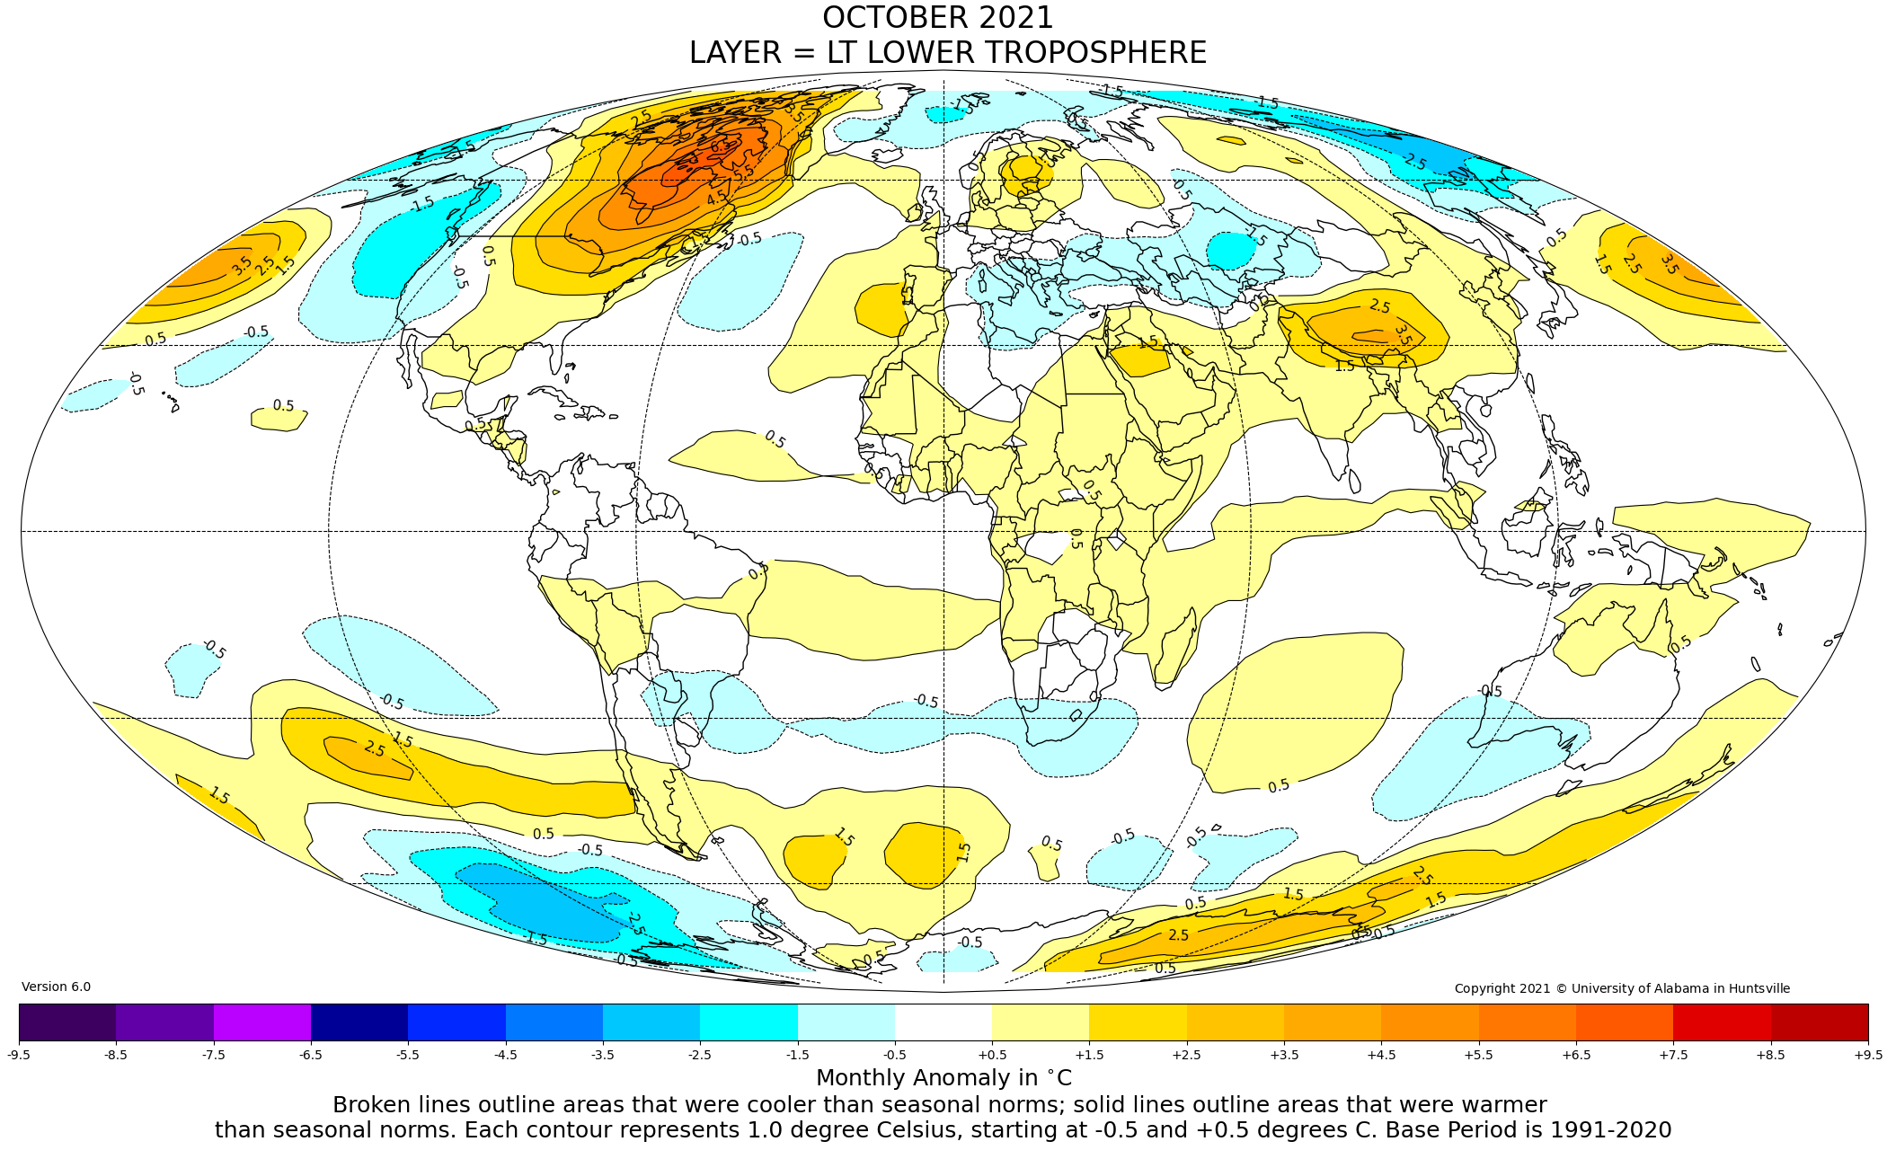
Figure. Lower tropospheric temperature anomalies for September 2021

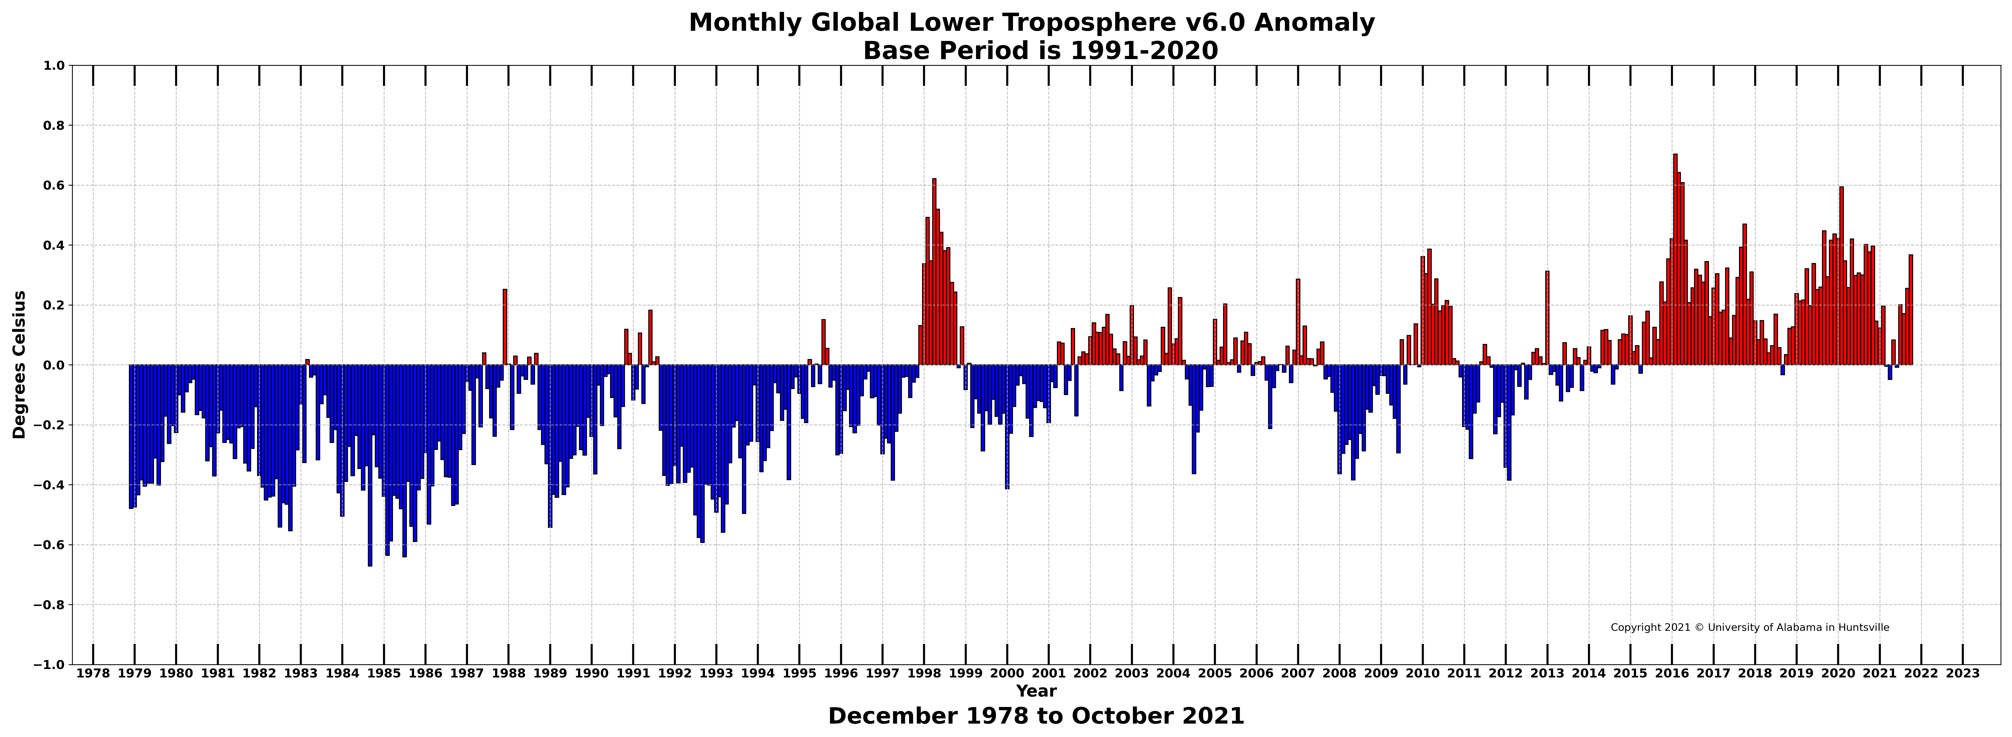

Figure. Bar chart of global monthly lower tropospheric temperature anomalies.

